**User Guide of Marvel Fan Home**

* **A website for Marvel Fans**

**Documentation History:**

|  |  |  |  |
| --- | --- | --- | --- |
| No. | Version | Publisher | Date |
| 1 | 1.0 (initial) | Yan Hao | 01/01/2017 |
| 2 |  |  |  |
| 3 |  |  |  |
| 4 |  |  |  |

Table of Contents

1. Home Page 3

2. Characters Search Page 4

Validation 4

3. Results Page 6

Set Result Limit 6

Sorting 7

Thumbnails 7

# 1. Home Page

There are four modules in universal header: Characters, Comics, Stories and Creators. Currently the module ‘**Characters**’ is ready to use while other ones are to be continued.

* Home page will play a video at background.
* The Marvel logo in header and Marvel text in footer link to **Marvel official website**.

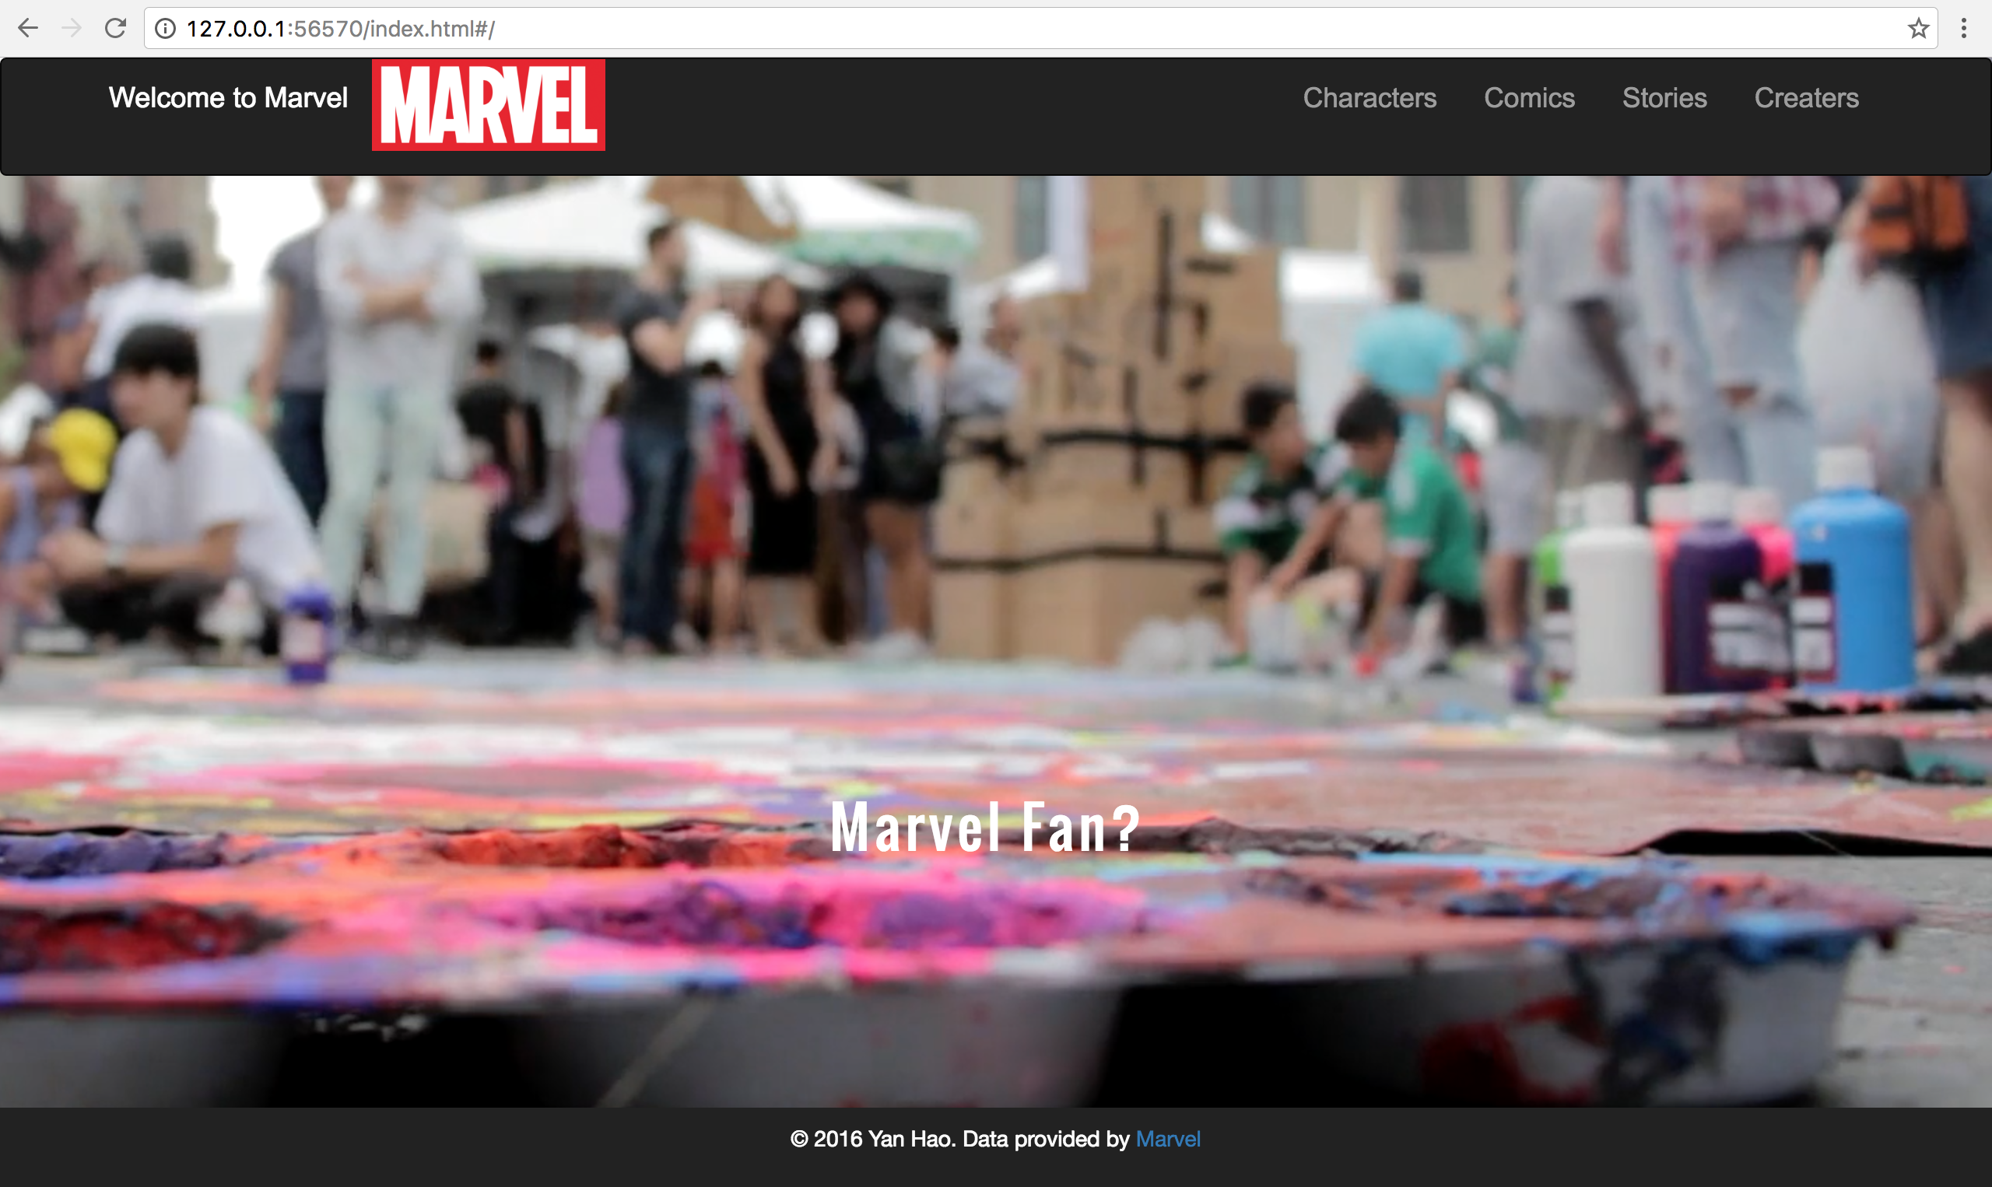

Modules except Characters are not ready yet:

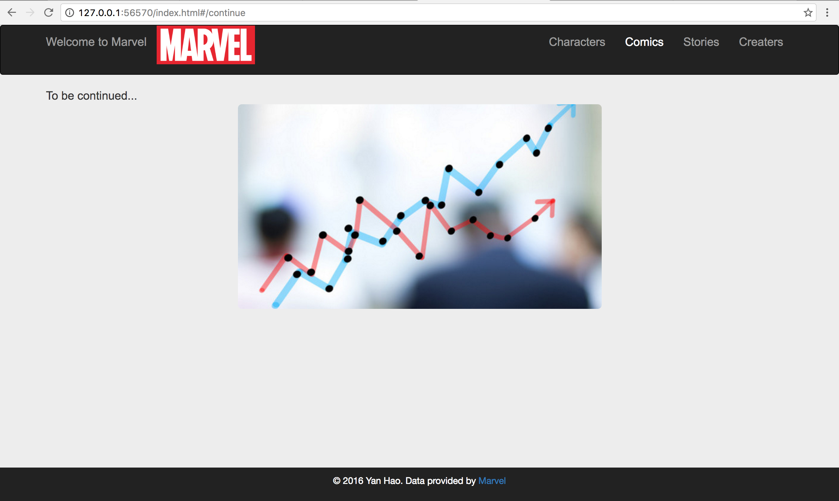

# 2. Characters Search Page

User can search characters by inputting a character name:

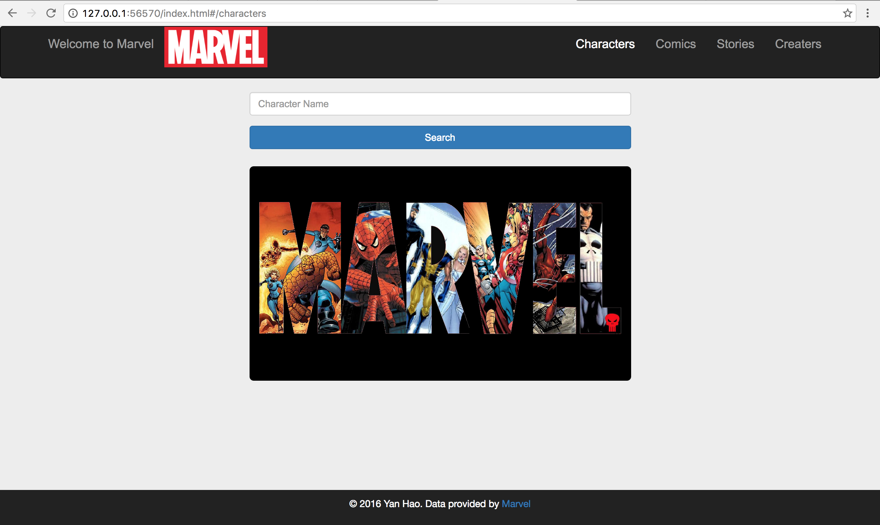

## Validation

Character name **cannot be empty**, if it is empty, a message will display near the search box:

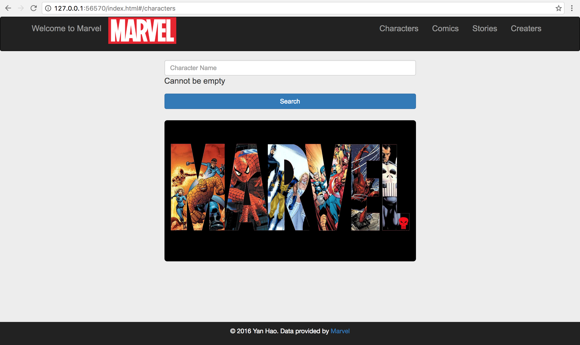

If there is **no matched result**, a message ‘Unable to find that character’ will display in result page:

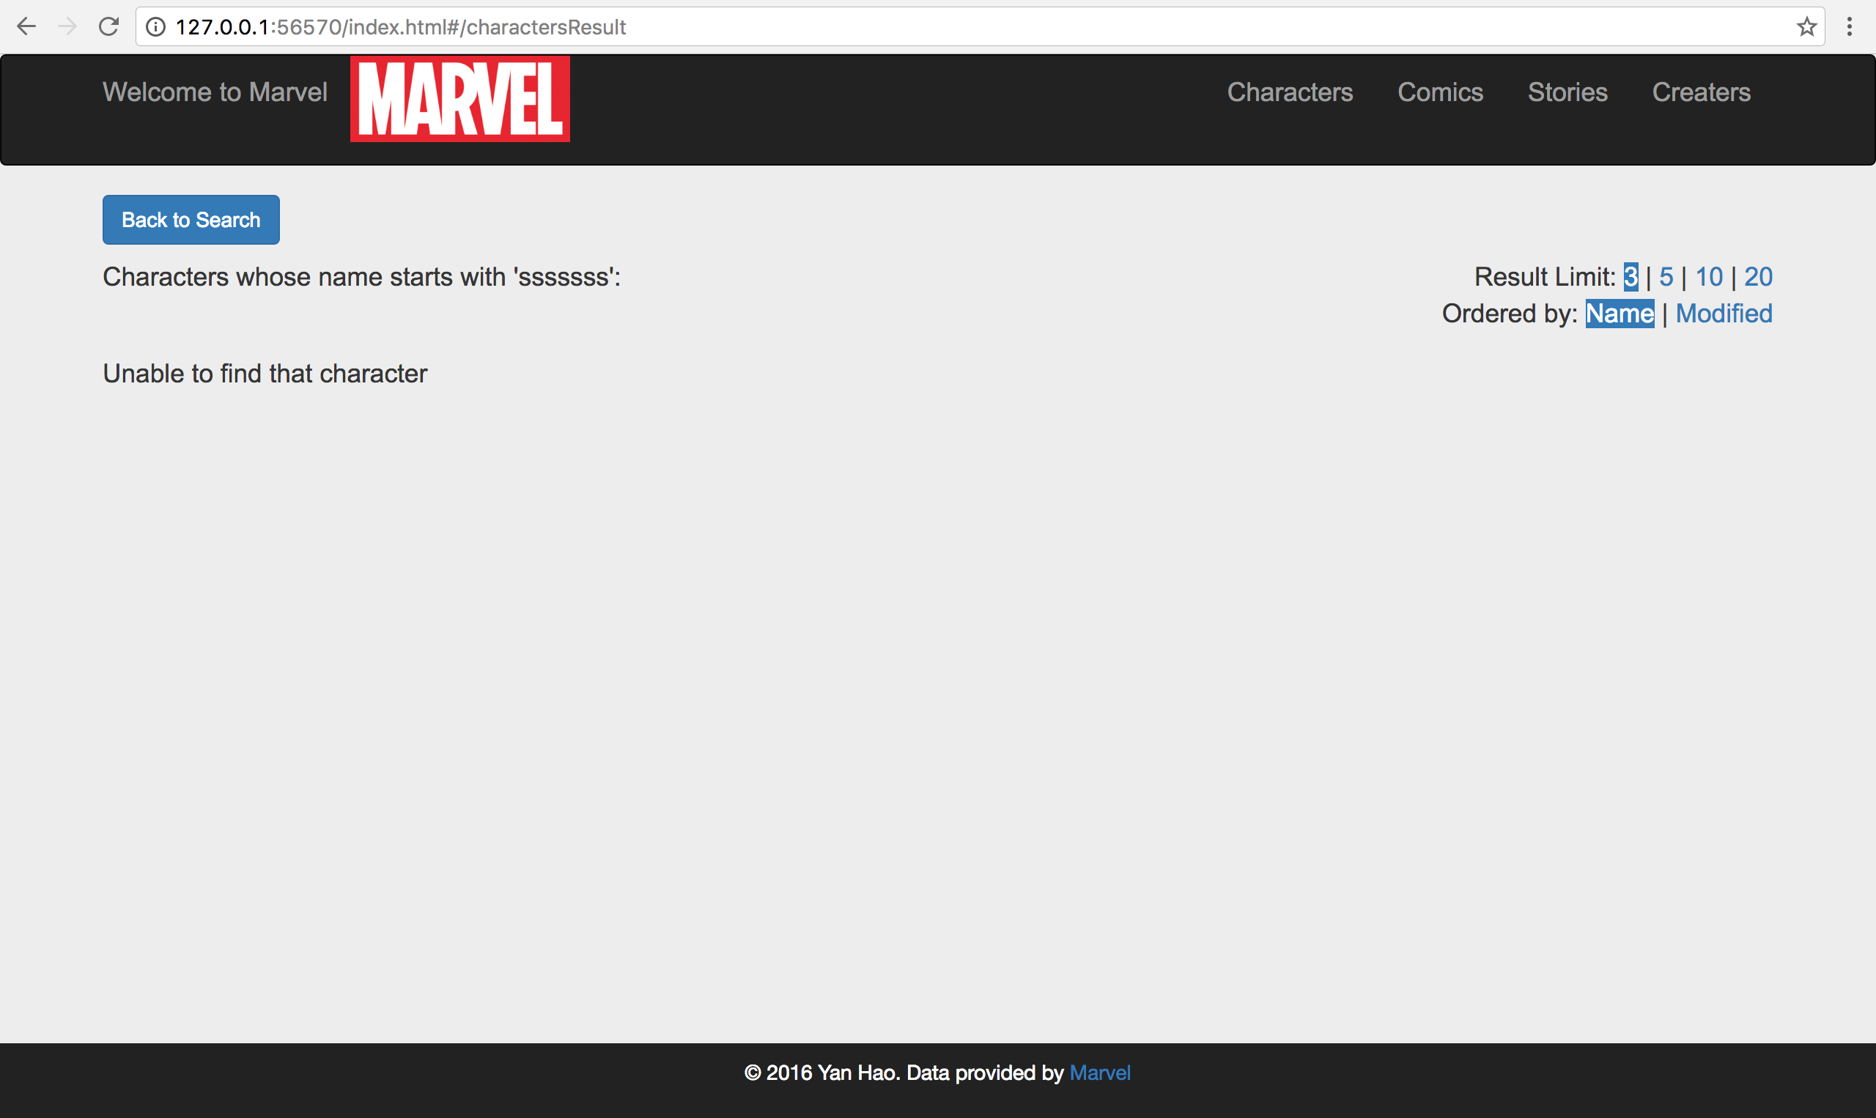

# 3. Results Page

Matched results will be listed (3 matched characters ordered by name will be listed as default).

In the character list, character name and ‘More Info’ link to Marvel official website of that character.

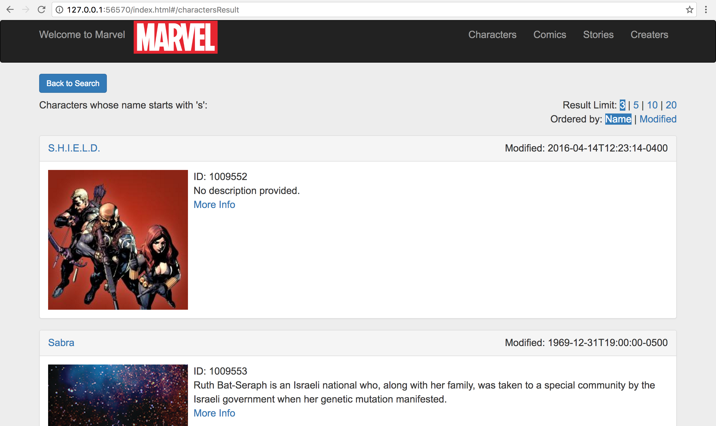

## Set Result Limit

User can change the number of showed results by clicking on the number 3, 5, 10 or 20:

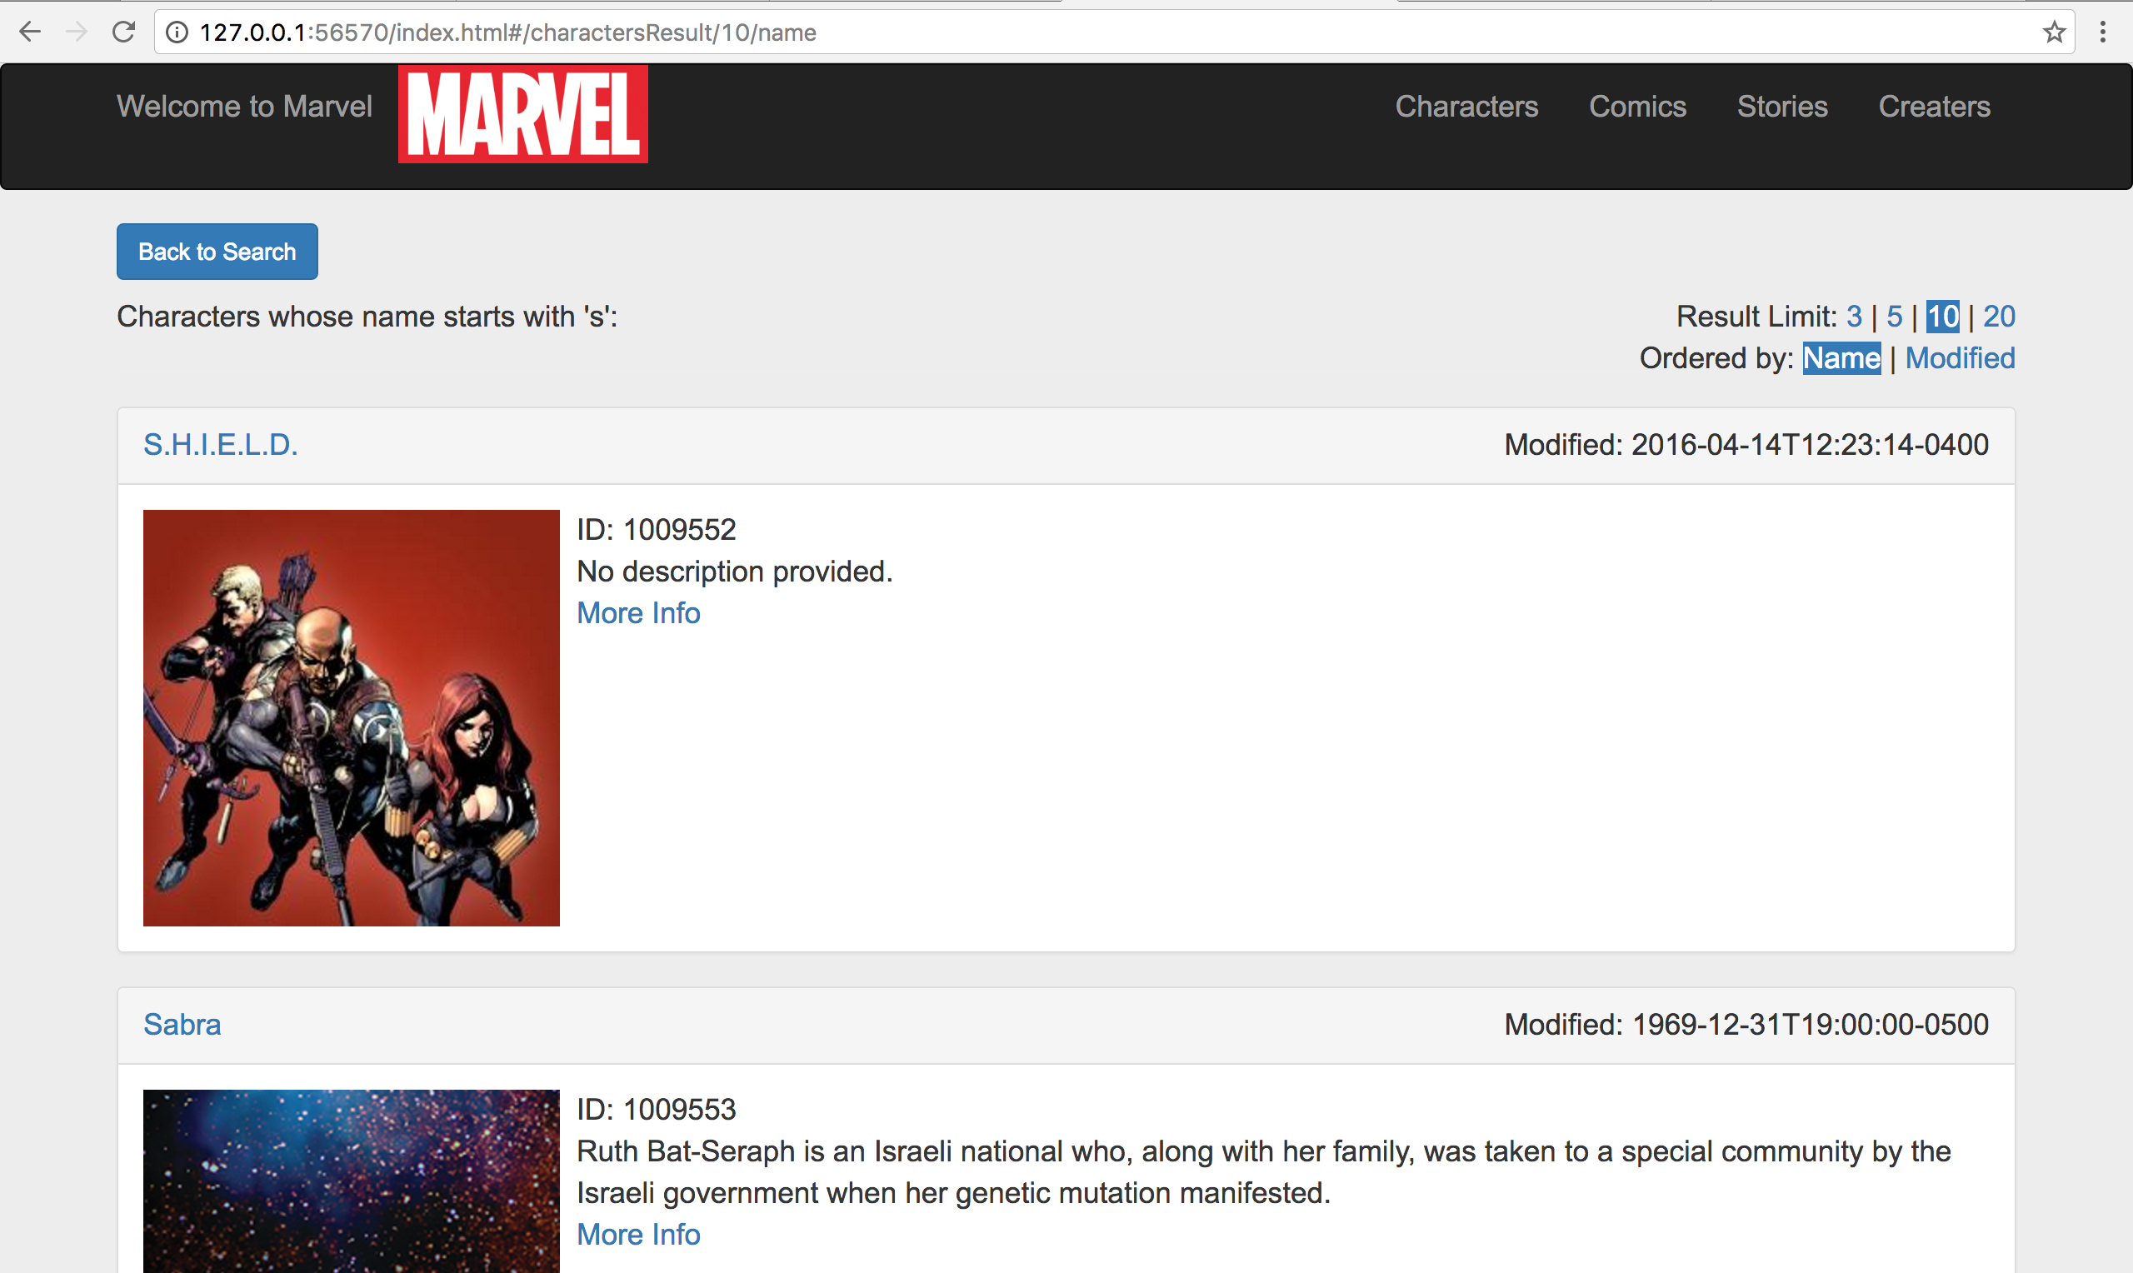

## Sorting

The matched characters can be ordered by name or modified time. Click the option ‘**Name**’ or ‘**Modified**’ on the right to change sorting.

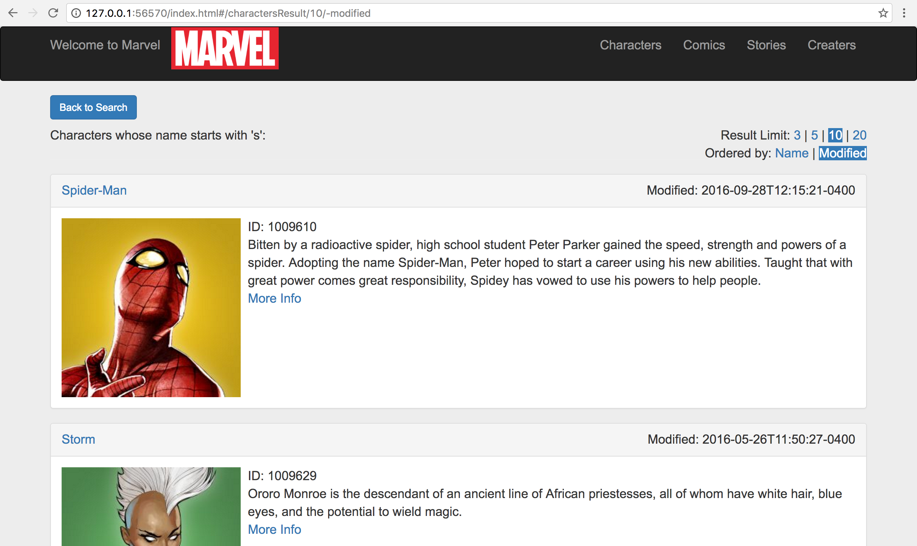

## Thumbnails

Users can see a **full size** version of the image by clicking on a thumbnail:

